SanDisk Portable SSD (Updated Firmware) - 1TB

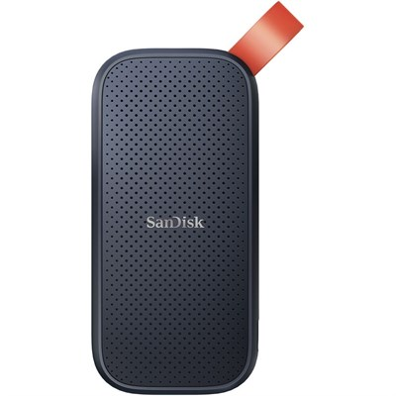

**Key Specifications**

* **Capacity**: 1TB
* **Interface**: USB 3.2 Gen 2 (Type-C)
* **Sequential Read Speed**: Up to 520 MB/s
* **Form Factor**: Portable SSD

**Performance Features:**

* **Fast File Transfers**:  
  High-speed USB interface enables quick data transfers, ideal for large files like videos and photos.
* **Updated Firmware**:  
  Ensures improved performance and compatibility with modern devices.

**Capacity and Storage:**

* **Storage Size**: 1TB of storage capacity, suitable for storing large files such as videos, photos, and documents.
* **Form Factor**: Compact and lightweight, designed for portability, with a slim profile for easy carrying.

**Warranty**

* Backed by a **3-year limited warranty**, ensuring reliability and customer support.